Yolov8轻量级：Next-vit，用于现实工业场景的下一代视觉 Transformer

1.Next-vit介绍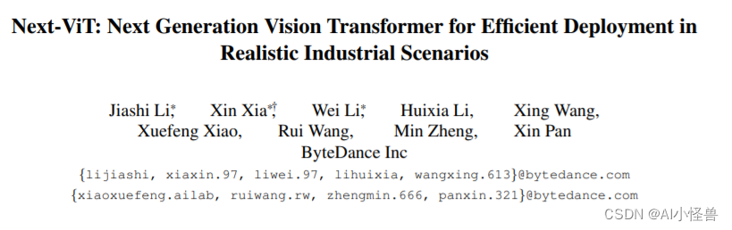
论文：https://arxiv.org/pdf/2207.05501.pdf
由于复杂的注意力机制和模型设计，大多数现有的视觉 Transformer（ViT）在现实的工业部署场景中不能像卷积神经网络（CNN）那样高效地执行。这就带来了一个问题：视觉神经网络能否像 CNN 一样快速推断并像 ViT 一样强大？
主要贡献总结如下：
1）开发了具有部署友好机制的强大卷积块和变换块，即NCB和NTB。Next-ViT堆栈NCB和NTB 构建先进的CNN-Transformer混合架构。
2）从一个新的角度设计了一种创新的CNN Transformer混合策略，该策略可以高效地提高性能。
3）介绍了Next ViT。大量实验证明了Next ViT的优势。它在TensorRT和CoreML上实现了图像分类、目标检测和语义分割的SOTA延迟/精度权衡。
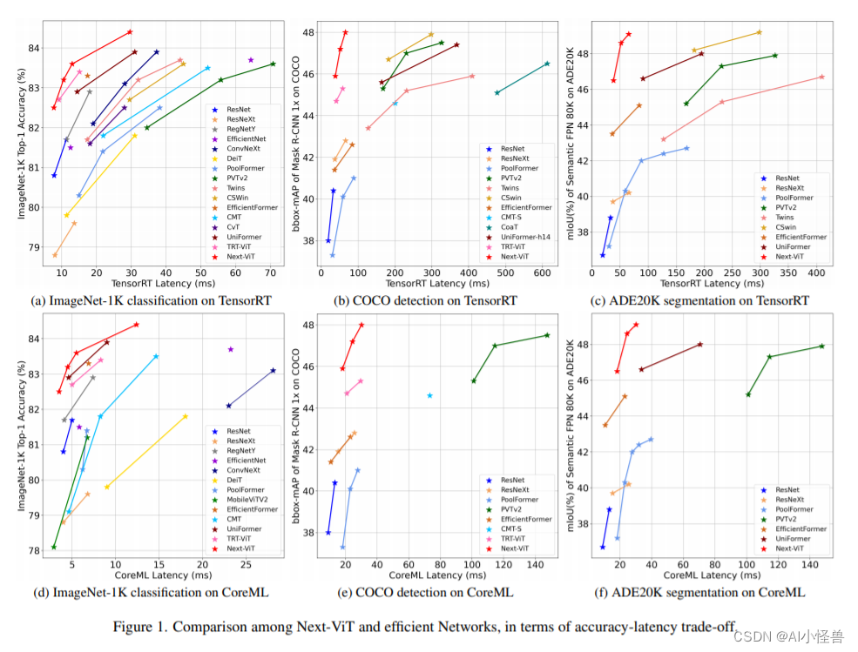 Next-ViT 的研究团队通过开发新型的卷积块（NCB）和 Transformer 块（NTB），部署了友好的机制来捕获局部和全局信息。然后，该研究提出了一种新型混合策略 NHS，旨在以高效的混合范式堆叠 NCB 和 NTB，从而提高各种下游任务的性能。
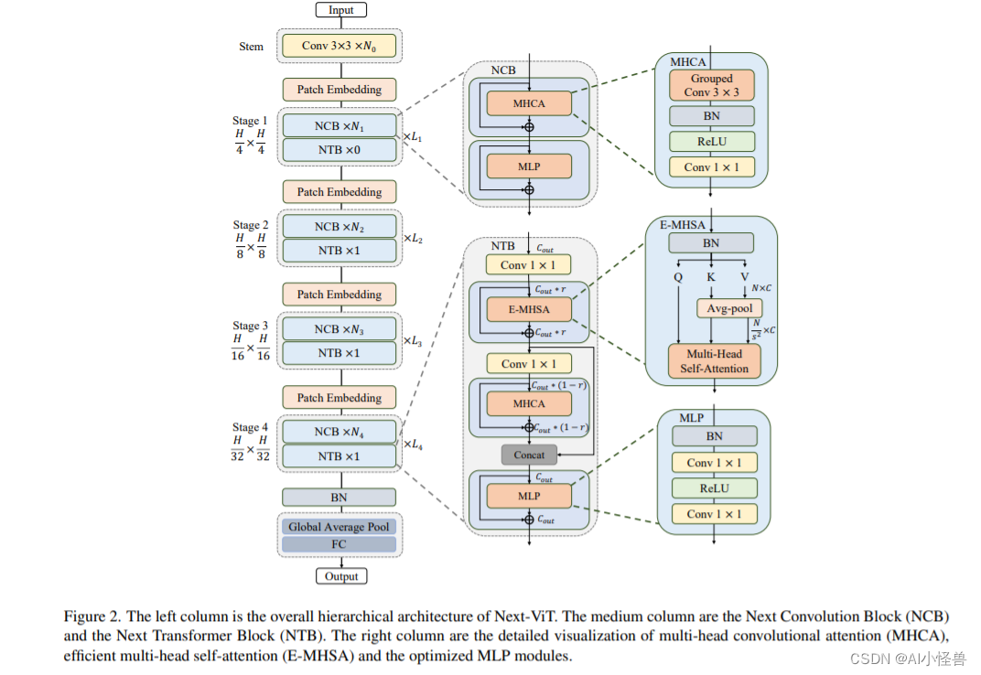
该研究提出了 Next Convolution Block (NCB)，它在保持 BottleNeck 块的部署优势的同时获得了 Transformer 块的突出性能。如图 3(f) 所示，NCB 遵循 MetaFormer （已被证实对 Transformer 块至关重要） 的一般架构。此外，一个高效的基于注意力的 token 混合器同样重要。该研究设计了一种多头卷积注意力（MHCA）作为部署卷积操作的高效 token 混合器，并在 MetaFormer 的范式中使用 MHCA 和 MLP 层构建 NCB。
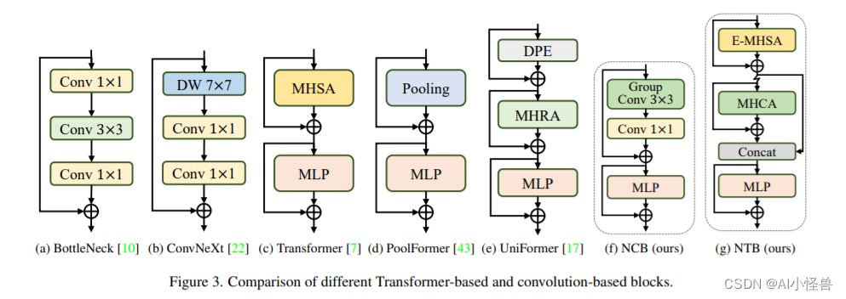
在目标检测和实例分割任务上，该研究将 Next-ViT 与 SOTA 模型进行了比较，结果如下表 6 所示。 大量实验表明，Next-ViT 在各种视觉任务的延迟 / 准确性权衡方面明显优于现有的 CNN、ViT 和 CNN-Transformer 混合架构。在 TensorRT 上，Next-ViT 与 ResNet 相比，在 COCO 检测任务上高出 5.4 mAP（40.4 VS 45.8），在 ADE20K 分割上高出 8.2% mIoU（38.8% VS 47.0%）。同时，Next-ViT 达到了与 CSWin 相当的性能，并且推理速度提高了 3.6 倍。在 CoreML 上，Next-ViT 在 COCO 检测任务上比 EfficientFormer 高出 4.6 mAP（42.6 VS 47.2），在 ADE20K 分割上高出 3.5% mIoU（从 45.2% 到 48.7%）。
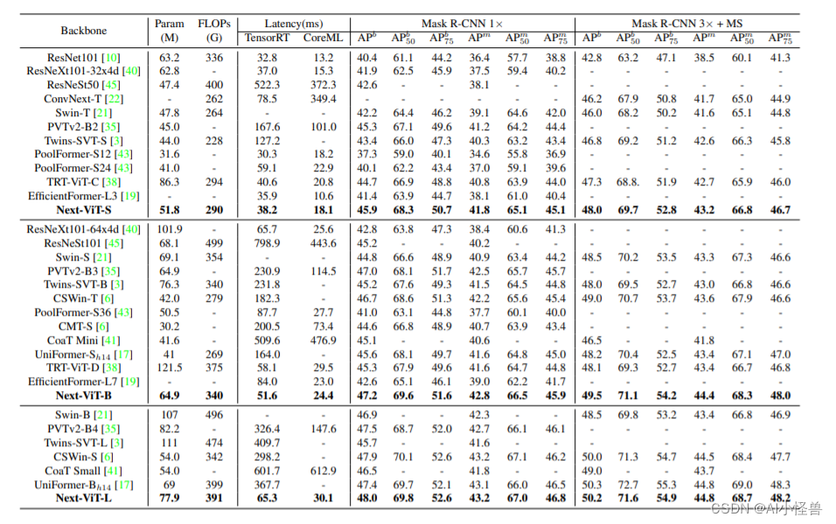
该研究可视化了 ResNet、Swin Transformer 和 Next-ViT 的输出特征的傅里叶谱和热图
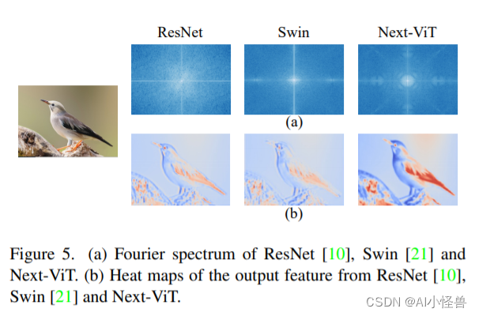
NCB 在所有三个任务上实现了最佳延迟 / 准确性权衡
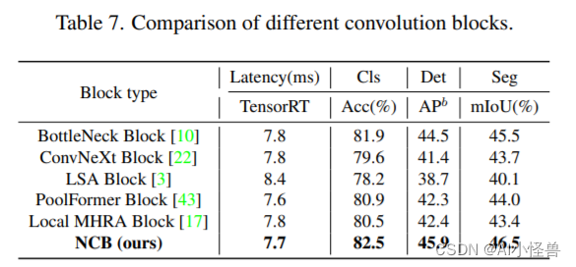
对于 NTB 块，该研究探讨了 NTB 的收缩率 r 对 Next-ViT 整体性能的影响，结果如下表 8 所示，减小收缩率 r 将减少模型延迟。
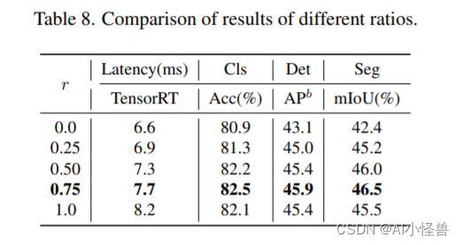

2.Next-vit引入到yolov8

2.1 加入ultralytics/nn/backbone/NextViT.py
# Copyright (c) ByteDance Inc. All rights reserved.
from functools import partial
import numpy as np
import torch
import torch.utils.checkpoint as checkpoint
from einops import rearrange
from timm.models.layers import DropPath, trunc_normal_
from torch import nn

__all__ = ['nextvit_small', 'nextvit_base', 'nextvit_large']

NORM_EPS = 1e-5

class ConvBNReLU(nn.Module):
def __init__(
self,
in_channels,
out_channels,
kernel_size,
stride,
groups=1):
super(ConvBNReLU, self).__init__()
self.conv = nn.Conv2d(in_channels, out_channels, kernel_size=kernel_size, stride=stride,
padding=1, groups=groups, bias=False)
self.norm = nn.BatchNorm2d(out_channels, eps=NORM_EPS)
self.act = nn.ReLU(inplace=True)

def forward(self, x):
x = self.conv(x)
x = self.norm(x)
x = self.act(x)
return x

def _make_divisible(v, divisor, min_value=None):
if min_value is None:
min_value = divisor
new_v = max(min_value, int(v + divisor / 2) // divisor * divisor)
# Make sure that round down does not go down by more than 10%.
if new_v < 0.9 * v:
new_v += divisor
return new_v

class PatchEmbed(nn.Module):
def __init__(self,
in_channels,
out_channels,
stride=1):
super(PatchEmbed, self).__init__()
norm_layer = partial(nn.BatchNorm2d, eps=NORM_EPS)
if stride == 2:
self.avgpool = nn.AvgPool2d((2, 2), stride=2, ceil_mode=True, count_include_pad=False)
self.conv = nn.Conv2d(in_channels, out_channels, kernel_size=1, stride=1, bias=False)
self.norm = norm_layer(out_channels)
elif in_channels != out_channels:
self.avgpool = nn.Identity()
self.conv = nn.Conv2d(in_channels, out_channels, kernel_size=1, stride=1, bias=False)
self.norm = norm_layer(out_channels)
else:
self.avgpool = nn.Identity()
self.conv = nn.Identity()
self.norm = nn.Identity()

def forward(self, x):
return self.norm(self.conv(self.avgpool(x)))

class MHCA(nn.Module):
"""
Multi-Head Convolutional Attention
"""
def __init__(self, out_channels, head_dim):
super(MHCA, self).__init__()
norm_layer = partial(nn.BatchNorm2d, eps=NORM_EPS)
self.group_conv3x3 = nn.Conv2d(out_channels, out_channels, kernel_size=3, stride=1,
padding=1, groups=out_channels // head_dim, bias=False)
self.norm = norm_layer(out_channels)
self.act = nn.ReLU(inplace=True)
self.projection = nn.Conv2d(out_channels, out_channels, kernel_size=1, bias=False)

def forward(self, x):
out = self.group_conv3x3(x)
out = self.norm(out)
out = self.act(out)
out = self.projection(out)
return out

class Mlp(nn.Module):
def __init__(self, in_features, out_features=None, mlp_ratio=None, drop=0., bias=True):
super().__init__()
out_features = out_features or in_features
hidden_dim = _make_divisible(in_features * mlp_ratio, 32)
self.conv1 = nn.Conv2d(in_features, hidden_dim, kernel_size=1, bias=bias)
self.act = nn.ReLU(inplace=True)
self.conv2 = nn.Conv2d(hidden_dim, out_features, kernel_size=1, bias=bias)
self.drop = nn.Dropout(drop)

def forward(self, x):
x = self.conv1(x)
x = self.act(x)
x = self.drop(x)
x = self.conv2(x)
x = self.drop(x)
return x

class NCB(nn.Module):
"""
Next Convolution Block
"""
def __init__(self, in_channels, out_channels, stride=1, path_dropout=0,
drop=0, head_dim=32, mlp_ratio=3):
super(NCB, self).__init__()
self.in_channels = in_channels
self.out_channels = out_channels
norm_layer = partial(nn.BatchNorm2d, eps=NORM_EPS)
assert out_channels % head_dim == 0

self.patch_embed = PatchEmbed(in_channels, out_channels, stride)
self.mhca = MHCA(out_channels, head_dim)
self.attention_path_dropout = DropPath(path_dropout)

self.norm = norm_layer(out_channels)
self.mlp = Mlp(out_channels, mlp_ratio=mlp_ratio, drop=drop, bias=True)
self.mlp_path_dropout = DropPath(path_dropout)
self.is_bn_merged = False

def forward(self, x):
x = self.patch_embed(x)
x = x + self.attention_path_dropout(self.mhca(x))
if not torch.onnx.is_in_onnx_export() and not self.is_bn_merged:
out = self.norm(x)
else:
out = x
x = x + self.mlp_path_dropout(self.mlp(out))
return x

class E_MHSA(nn.Module):
"""
Efficient Multi-Head Self Attention
"""
def __init__(self, dim, out_dim=None, head_dim=32, qkv_bias=True, qk_scale=None,
attn_drop=0, proj_drop=0., sr_ratio=1):
super().__init__()
self.dim = dim
self.out_dim = out_dim if out_dim is not None else dim
self.num_heads = self.dim // head_dim
self.scale = qk_scale or head_dim ** -0.5
self.q = nn.Linear(dim, self.dim, bias=qkv_bias)
self.k = nn.Linear(dim, self.dim, bias=qkv_bias)
self.v = nn.Linear(dim, self.dim, bias=qkv_bias)
self.proj = nn.Linear(self.dim, self.out_dim)
self.attn_drop = nn.Dropout(attn_drop)
self.proj_drop = nn.Dropout(proj_drop)

self.sr_ratio = sr_ratio
self.N_ratio = sr_ratio ** 2
if sr_ratio > 1:
self.sr = nn.AvgPool1d(kernel_size=self.N_ratio, stride=self.N_ratio)
self.norm = nn.BatchNorm1d(dim, eps=NORM_EPS)
self.is_bn_merged = False

def forward(self, x):
B, N, C = x.shape
q = self.q(x)
q = q.reshape(B, N, self.num_heads, int(C // self.num_heads)).permute(0, 2, 1, 3)

if self.sr_ratio > 1:
x_ = x.transpose(1, 2)
x_ = self.sr(x_)
if not torch.onnx.is_in_onnx_export() and not self.is_bn_merged:
x_ = self.norm(x_)
x_ = x_.transpose(1, 2)
k = self.k(x_)
k = k.reshape(B, -1, self.num_heads, int(C // self.num_heads)).permute(0, 2, 3, 1)
v = self.v(x_)
v = v.reshape(B, -1, self.num_heads, int(C // self.num_heads)).permute(0, 2, 1, 3)
else:
k = self.k(x)
k = k.reshape(B, -1, self.num_heads, int(C // self.num_heads)).permute(0, 2, 3, 1)
v = self.v(x)
v = v.reshape(B, -1, self.num_heads, int(C // self.num_heads)).permute(0, 2, 1, 3)
attn = (q @ k) * self.scale

attn = attn.softmax(dim=-1)
attn = self.attn_drop(attn)

x = (attn @ v).transpose(1, 2).reshape(B, N, C)
x = self.proj(x)
x = self.proj_drop(x)
return x

class NTB(nn.Module):
"""
Next Transformer Block
"""
def __init__(
self, in_channels, out_channels, path_dropout=0.1, stride=1, sr_ratio=1,
mlp_ratio=2, head_dim=32, mix_block_ratio=0.75, attn_drop=0, drop=0,
):
super(NTB, self).__init__()
self.in_channels = in_channels
self.out_channels = out_channels
self.mix_block_ratio = mix_block_ratio
norm_func = partial(nn.BatchNorm2d, eps=NORM_EPS)

self.mhsa_out_channels = _make_divisible(int(out_channels * mix_block_ratio), 32)
self.mhca_out_channels = out_channels - self.mhsa_out_channels

self.patch_embed = PatchEmbed(in_channels, self.mhsa_out_channels, stride)
self.norm1 = norm_func(self.mhsa_out_channels)
self.e_mhsa = E_MHSA(self.mhsa_out_channels, head_dim=head_dim, sr_ratio=sr_ratio,
attn_drop=attn_drop, proj_drop=drop)
self.mhsa_path_dropout = DropPath(path_dropout * mix_block_ratio)

self.projection = PatchEmbed(self.mhsa_out_channels, self.mhca_out_channels, stride=1)
self.mhca = MHCA(self.mhca_out_channels, head_dim=head_dim)
self.mhca_path_dropout = DropPath(path_dropout * (1 - mix_block_ratio))

self.norm2 = norm_func(out_channels)
self.mlp = Mlp(out_channels, mlp_ratio=mlp_ratio, drop=drop)
self.mlp_path_dropout = DropPath(path_dropout)

self.is_bn_merged = False

def forward(self, x):
x = self.patch_embed(x)
B, C, H, W = x.shape
if not torch.onnx.is_in_onnx_export() and not self.is_bn_merged:
out = self.norm1(x)
else:
out = x
out = rearrange(out, "b c h w -> b (h w) c") # b n c
out = self.mhsa_path_dropout(self.e_mhsa(out))
x = x + rearrange(out, "b (h w) c -> b c h w", h=H)

out = self.projection(x)
out = out + self.mhca_path_dropout(self.mhca(out))
x = torch.cat([x, out], dim=1)

if not torch.onnx.is_in_onnx_export() and not self.is_bn_merged:
out = self.norm2(x)
else:
out = x
x = x + self.mlp_path_dropout(self.mlp(out))
return x

class NextViT(nn.Module):
def __init__(self, stem_chs, depths, path_dropout, attn_drop=0, drop=0, num_classes=1000,
strides=[1, 2, 2, 2], sr_ratios=[8, 4, 2, 1], head_dim=32, mix_block_ratio=0.75,
use_checkpoint=False):
super(NextViT, self).__init__()
self.use_checkpoint = use_checkpoint

self.stage_out_channels = [[96] * (depths[0]),
[192] * (depths[1] - 1) + [256],
[384, 384, 384, 384, 512] * (depths[2] // 5),
[768] * (depths[3] - 1) + [1024]]

# Next Hybrid Strategy
self.stage_block_types = [[NCB] * depths[0],
[NCB] * (depths[1] - 1) + [NTB],
[NCB, NCB, NCB, NCB, NTB] * (depths[2] // 5),
[NCB] * (depths[3] - 1) + [NTB]]

self.stem = nn.Sequential(
ConvBNReLU(3, stem_chs[0], kernel_size=3, stride=2),
ConvBNReLU(stem_chs[0], stem_chs[1], kernel_size=3, stride=1),
ConvBNReLU(stem_chs[1], stem_chs[2], kernel_size=3, stride=1),
ConvBNReLU(stem_chs[2], stem_chs[2], kernel_size=3, stride=2),
)
input_channel = stem_chs[-1]
features = []
idx = 0
dpr = [x.item() for x in torch.linspace(0, path_dropout, sum(depths))] # stochastic depth decay rule
for stage_id in range(len(depths)):
numrepeat = depths[stage_id]
output_channels = self.stage_out_channels[stage_id]
block_types = self.stage_block_types[stage_id]
for block_id in range(numrepeat):
if strides[stage_id] == 2 and block_id == 0:
stride = 2
else:
stride = 1
output_channel = output_channels[block_id]
block_type = block_types[block_id]
if block_type is NCB:
layer = NCB(input_channel, output_channel, stride=stride, path_dropout=dpr[idx + block_id],
drop=drop, head_dim=head_dim)
features.append(layer)
elif block_type is NTB:
layer = NTB(input_channel, output_channel, path_dropout=dpr[idx + block_id], stride=stride,
sr_ratio=sr_ratios[stage_id], head_dim=head_dim, mix_block_ratio=mix_block_ratio,
attn_drop=attn_drop, drop=drop)
features.append(layer)
input_channel = output_channel
idx += numrepeat
self.features = nn.Sequential(*features)

self.norm = nn.BatchNorm2d(output_channel, eps=NORM_EPS)
self.stage_out_idx = [sum(depths[:idx + 1]) - 1 for idx in range(len(depths))]
self.channel = [i.size(1) for i in self.forward(torch.randn(1, 3, 640, 640))]
self._initialize_weights()

def _initialize_weights(self):
for n, m in self.named_modules():
if isinstance(m, (nn.BatchNorm2d, nn.GroupNorm, nn.LayerNorm, nn.BatchNorm1d)):
nn.init.constant_(m.weight, 1.0)
nn.init.constant_(m.bias, 0)
elif isinstance(m, nn.Linear):
trunc_normal_(m.weight, std=.02)
if hasattr(m, 'bias') and m.bias is not None:
nn.init.constant_(m.bias, 0)
elif isinstance(m, nn.Conv2d):
trunc_normal_(m.weight, std=.02)
if hasattr(m, 'bias') and m.bias is not None:
nn.init.constant_(m.bias, 0)

def forward(self, x):
res = []
x = self.stem(x)
for idx, layer in enumerate(self.features):
if self.use_checkpoint:
x = checkpoint.checkpoint(layer, x)
else:
x = layer(x)
if idx in self.stage_out_idx:
res.append(x)
res[-1] = self.norm(res[-1])
return res

def update_weight(model_dict, weight_dict):
idx, temp_dict = 0, {}
for k, v in weight_dict.items():
if k in model_dict.keys() and np.shape(model_dict[k]) == np.shape(v):
temp_dict[k] = v
idx += 1
model_dict.update(temp_dict)
print(f'loading weights... {idx}/{len(model_dict)} items')
return model_dict

def nextvit_small(weights=''):
model = NextViT(stem_chs=[64, 32, 64], depths=[3, 4, 10, 3], path_dropout=0.1)
if weights:
pretrained_weight = torch.load(weights)['model']
model.load_state_dict(update_weight(model.state_dict(), pretrained_weight))
return model

def nextvit_base(weights=''):
model = NextViT(stem_chs=[64, 32, 64], depths=[3, 4, 20, 3], path_dropout=0.2)
if weights:
pretrained_weight = torch.load(weights)['model']
model.load_state_dict(update_weight(model.state_dict(), pretrained_weight))
return model

def nextvit_large(weights=''):
model = NextViT(stem_chs=[64, 32, 64], depths=[3, 4, 30, 3], path_dropout=0.2)
if weights:
pretrained_weight = torch.load(weights)['model']
model.load_state_dict(update_weight(model.state_dict(), pretrained_weight))
return model

2.2 tasks.py注册
from ultralytics.nn.backbone.NextViT import *
def parse_model(d, ch, verbose=True): # model_dict, input_channels(3)（建议直接替换）
def parse_model(d, ch, verbose=True): # model_dict, input_channels(3)
# Parse a YOLO model.yaml dictionary into a PyTorch model
import ast

# Args
max_channels = float('inf')
nc, act, scales = (d.get(x) for x in ('nc', 'act', 'scales'))
depth, width = (d.get(x, 1.0) for x in ('depth_multiple', 'width_multiple'))
if scales:
scale = d.get('scale')
if not scale:
scale = tuple(scales.keys())[0]
LOGGER.warning(f"WARNING ⚠️ no model scale passed. Assuming scale='{scale}'.")
depth, width, max_channels = scales[scale]

if act:
Conv.default_act = eval(act) # redefine default activation, i.e. Conv.default_act = nn.SiLU()
if verbose:
LOGGER.info(f"{colorstr('activation:')} {act}") # print

if verbose:
LOGGER.info(f"\n{'':>3}{'from':>20}{'n':>3}{'params':>10} {'module':<45}{'arguments':<30}")
ch = [ch]

is_backbone = False

layers, save, c2 = [], [], ch[-1] # layers, savelist, ch out
for i, (f, n, m, args) in enumerate(d['backbone'] + d['head']): # from, number, module, args
#m = getattr(torch.nn, m[3:]) if 'nn.' in m else globals()[m] # get module
try:
t = m
m = eval(m) if isinstance(m, str) else m # eval strings
except:
pass

for j, a in enumerate(args):
with contextlib.suppress(NameError):
try:
args[j] = eval(a) if isinstance(a, str) else a # eval strings
except:
args[j] = a

# args[j] = eval(a) if isinstance(a, str) else a # eval strings

n = n_ = max(round(n * depth), 1) if n > 1 else n # depth gain
if m in (Classify, Conv, ConvTranspose, GhostConv, Bottleneck, GhostBottleneck, SPP, SPPF, DWConv, Focus,
BottleneckCSP, C1, C2, C2f, C3, C3TR, C3Ghost, nn.ConvTranspose2d, DWConvTranspose2d, C3x):
c1, c2 = ch[f], args[0]
if c2 != nc: # if c2 not equal to number of classes (i.e. for Classify() output)
c2 = make_divisible(min(c2, max_channels) * width, 8)

args = [c1, c2, *args[1:]]
if m in (BottleneckCSP, C1, C2, C2f, C3, C3TR, C3Ghost, C3x):
args.insert(2, n) # number of repeats
n = 1
elif m is nn.BatchNorm2d:
args = [ch[f]]
elif m is Concat:
c2 = sum(ch[x] for x in f)
elif isinstance(m, str):
t = m
m = timm.create_model(m, pretrained=args[0], features_only=True)
c2 = m.feature_info.channels()
elif m in {nextvit_small,nextvit_base,nextvit_large}: #ng
m = m(*args)
c2 = m.channel
elif m in [BiFPN_Concat2,BiFPN_Concat3]:
c2 = sum(ch[x] for x in f)
elif m in (Detect, Segment):
args.append([ch[x] for x in f])
if m is Segment:
args[2] = make_divisible(min(args[2], max_channels) * width, 8)
else:
c2 = ch[f]
if isinstance(c2, list):
is_backbone = True
m_ = m
m_.backbone = True
else:
m_ = nn.Sequential(*(m(*args) for _ in range(n))) if n > 1 else m(*args) # module
t = str(m)[8:-2].replace('__main__.', '') # module type

#m_ = nn.Sequential(*(m(*args) for _ in range(n))) if n > 1 else m(*args) # module
#t = str(m)[8:-2].replace('__main__.', '') # module type
m.np = sum(x.numel() for x in m_.parameters()) # number params
#m_.i, m_.f, m_.type = i, f, t # attach index, 'from' index, type
m_.i, m_.f, m_.type = i + 4 if is_backbone else i, f, t
if verbose:
LOGGER.info(f'{i:>3}{str(f):>20}{n_:>3}{m.np:10.0f} {t:<45}{str(args):<30}') # print
#save.extend(x % i for x in ([f] if isinstance(f, int) else f) if x != -1) # append to savelist
save.extend(x % (i + 4 if is_backbone else i) for x in ([f] if isinstance(f, int) else f) if
x != -1) # append to savelist
layers.append(m_)
if i == 0:
ch = []
if isinstance(c2, list):
ch.extend(c2)
for _ in range(5 - len(ch)):
ch.insert(0, 0)
else:
ch.append(c2)
return nn.Sequential(*layers), sorted(save)
def _forward_once(self, x, profile=False, visualize=False):（建议直接替换）
def _forward_once(self, x, profile=False, visualize=False):
"""
Perform a forward pass through the network.
Args:
x (torch.Tensor): The input tensor to the model
profile (bool): Print the computation time of each layer if True, defaults to False.
visualize (bool): Save the feature maps of the model if True, defaults to False
Returns:
(torch.Tensor): The last output of the model.
"""
y, dt = [], [] # outputs
for m in self.model:
if m.f != -1: # if not from previous layer
x = y[m.f] if isinstance(m.f, int) else [x if j == -1 else y[j] for j in m.f] # from earlier layers
if profile:
self._profile_one_layer(m, x, dt)
if hasattr(m, 'backbone'):
x = m(x)
for _ in range(5 - len(x)):
x.insert(0, None)
for i_idx, i in enumerate(x):
if i_idx in self.save:
y.append(i)
else:
y.append(None)
x = x[-1]
else:
x = m(x) # run
y.append(x if m.i in self.save else None) # save output
if visualize:
LOGGER.info('visualize feature not yet supported')
# TODO: feature_visualization(x, m.type, m.i, save_dir=visualize)
return x

2.3 yolov8_NextViT.yaml
# Ultralytics YOLO 🚀, GPL-3.0 license
# YOLOv8 object detection model with P3-P5 outputs. For Usage examples see https://docs.ultralytics.com/tasks/detect

# Parameters
nc: 1 # number of classes
scales: # model compound scaling constants, i.e. 'model=yolov8n.yaml' will call yolov8.yaml with scale 'n'
# [depth, width, max_channels]
n: [0.33, 0.25, 1024] # YOLOv8n summary: 225 layers, 3157200 parameters, 3157184 gradients, 8.9 GFLOPs
s: [0.33, 0.50, 1024] # YOLOv8s summary: 225 layers, 11166560 parameters, 11166544 gradients, 28.8 GFLOPs
m: [0.67, 0.75, 768] # YOLOv8m summary: 295 layers, 25902640 parameters, 25902624 gradients, 79.3 GFLOPs
l: [1.00, 1.00, 512] # YOLOv8l summary: 365 layers, 43691520 parameters, 43691504 gradients, 165.7 GFLOPs
x: [1.00, 1.25, 512] # YOLOv8x summary: 365 layers, 68229648 parameters, 68229632 gradients, 258.5 GFLOPs

# YOLOv8.0n backbone
backbone:
# [from, repeats, module, args]
- [-1, 1, nextvit_small, []] # 0-P1/2
- [-1, 1, SPPF, [1024, 5]] # 5

# YOLOv8.0n head
head:
- [-1, 1, nn.Upsample, [None, 2, 'nearest']]
- [[-1, 3], 1, Concat, [1]] # cat backbone P4
- [-1, 3, C2f, [512]] # 8

- [-1, 1, nn.Upsample, [None, 2, 'nearest']]
- [[-1, 2], 1, Concat, [1]] # cat backbone P3
- [-1, 3, C2f, [256]] # 11 (P3/8-small)

- [-1, 1, Conv, [256, 3, 2]]
- [[-1, 8], 1, Concat, [1]] # cat head P4
- [-1, 3, C2f, [512]] # 14 (P4/16-medium)

- [-1, 1, Conv, [512, 3, 2]]
- [[-1, 5], 1, Concat, [1]] # cat head P5
- [-1, 3, C2f, [1024]] # 17 (P5/32-large)

- [[11, 14, 17], 1, Detect, [nc]] # Detect(P3, P4, P5)

